SIMATS ENGINEERING
ASSESSMENT TOOL 1

COURSE NAME: Database Management Systems
COURSE CODE: CSA05

COURSE OUTCOME COVERED
CO1: Analyze DBMS architecture, different data models, schema types, and design
ER/EER diagrams, relational schemas for case-based scenarios by identifying
entities and relationships. (BL1, BL2)
Activity Tool : Short Answer Text(High)
Assessment Tool Weightage: 30%

QUESTIONS

UPS Product Tracking Information System UPS prides itself on having up-to-date information on the processing and current location of each shipped item. To do this, UPS relies on a company-wide information system. Shipped items are the heart of the UPS product tracking information system. Shipped items can be characterized by item number (unique), weight, dimensions, insurance amount, destination, and final delivery date. Shipped items are received into the UPS system at a single retail center. Retail centers are characterized by their type, uniqueID, and address. Shipped items make their way to their destination via one or more standard UPS transportation events (i.e., flights, truck deliveries). These transportation events are characterized by a unique scheduleNumber, a type (e.g, flight, truck), and a deliveryRoute. Create an Entity Relationship diagram that captures this information about the UPS system.

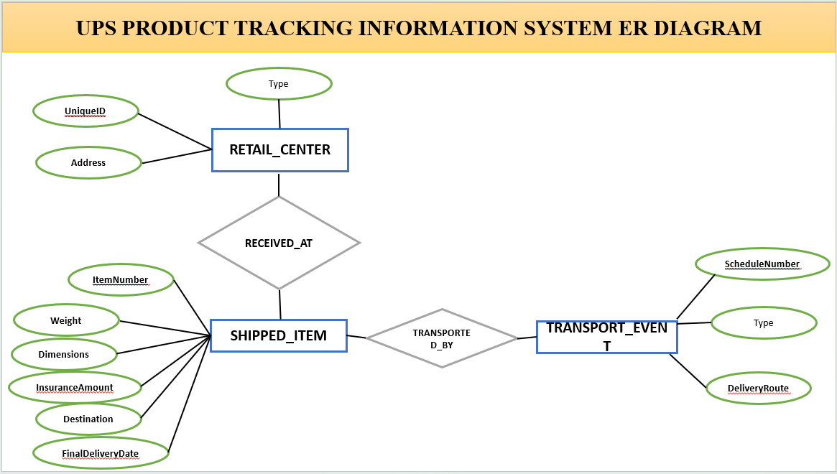

Code of Conduct:
I ______M.V.PREETHASHRI(192524476)______________ (Name / Reg No) certify that this submission is my original work and that I have adhered to the guidelines specified for this assessment.
I understand that any violation of academic integrity rules will result in disciplinary
action.
Signature of the student: M.V.PREETHASHRI

